RESSAC
Case study: Complex System On Chip (SoC) implementation

Domain: Hardware

Context and purpose

In the context of µXAV design HBS sub-system requests a lot of complex hardware functions to be implemented, associated to software treatment supported by complex microcontroller(s).
This software part is not concern by this study.

All these functions (here called elementary blocks) can be merged in a single complex hardware component, named a System On Chip, built on a FPGA bases architecture and using extensively hardware items from various sources (internal designs, COTS, IPs from others domains, function libraries, automatically generated HDL code from model …).

The purpose of this usecase is to describe a SoC design flow that guarantee a design assurance level of type A, despite the great disparity of elementary block sources (most of them could be totally out of the classical avionic design context).

This process is an extension of what is considered as acceptable for complex COTS, COTS IP or simple component.

SW development associated to SoC microcontroller is out of this development process description.

Equipment & Board Process development is out of the scope of this case study, which will emphasize on SoC development itself.

Equipment & Board Process will be described in another usecase slice, taking credit from the current SoC usecase.

Expected benefits
Streamlined aspects of the proposed process
- Concurrent Engineering / Agile method for accelerated development, by splitting a high level of complexity design into separate and comprehensive items.
- Enable usage of non-avionic domain robust commercial items (from automotive, computer …) that have been extensively used and demonstrated elsewhere.
- Limit the design demonstration to be provided for these items and focused on product verification evidences
- Limit the need for Design Tool Qualification, due to more product oriented approach
Assumptions :
- SoC functionalities shall be decomposable into Elementary Blocks (MAC Ethernet COTS IP, multiplier, image processing algorithm, filtering, mathematical function, Memory Controller,…).
- Elementary block should be observable at SoC level and can be individually modeled.
- High level of concurrent activities (concurrent teams, external sources)
- Focus on System Integration tasks.
- Risk based approach for sizing the team and effort.
- Product oriented approach at Elementary blocks.
Current standards issues:

Applicable standards: DO254, EASA CM - SWCEH – 001 (AEH), A(M)C 20-152A

Difficulties to apply this approach in application of current standards:
- Concurrent Engineering involving customer interaction not well aligned with DO-254 Sequential development (e.g. SOIx sequencing)
- DO254 compliance is not established for most of the elementary blocks (especially regarding design objectives as described in DO254 table A-1)
- Tool Qualification is not planned for dedicated tools used for items design
- Product approach vs. Process approach.

Compliance demonstration could be based on
- DO254 process and associated sequencing is performed at SoC top level (equivalent to an hardware equipment integration level, or an board assembly level)
- Elementary blocks are of manageable complexity and are handled as COTS or trustable IPs.
- Demonstration is not based on design tool qualification but on product verification (as for COTS or IPs)
- Elementary blocks are of manageable complexity. Process oriented approach is applied at integration level/top level

Process description

SoC design is made of 3 different steps that allow concurrent and incremental approach in order to optimize delay and resources.
First process concerns the System description (specification and architecture) according to needs expressed by the customer. A particular attention is put on architecture allocation to “elementary objects” that can be then designed from a large variety of sources.
A major point is the necessity to adopt a standardization approach for interfaces and communication between elementary blocks (internal busses, clock system, reset system);

The second part of the process is related to elementary block disposition that may be the result of various processes depending on provider and type of block source (COTS, IP, automatic generation, library …). This selection step is risk based and has a single objective: to make available a trusty and proven object that can be implemented in the SoC.

Last part of the process consists in incremental integration of each elementary block when available (integration means here implementation and verification).
Life cycle overview

The following figure shows SoC development process described in the following sections..

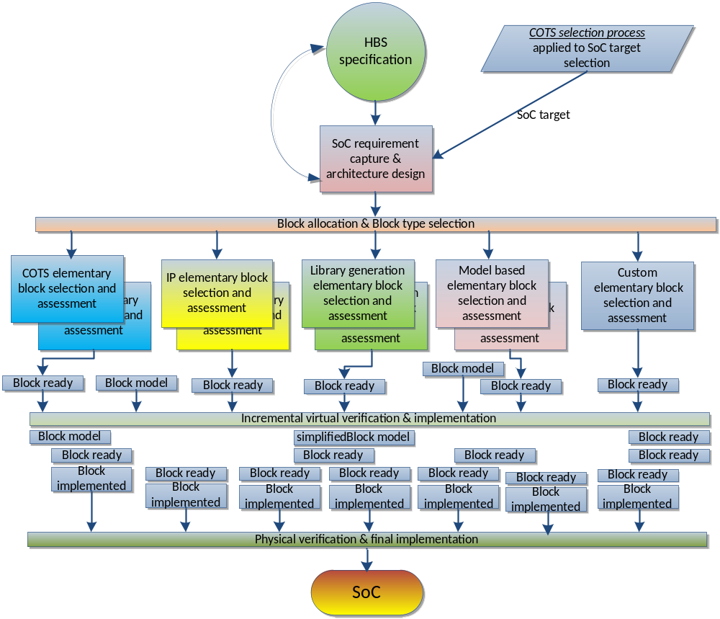

Planning Process

Typically the first process/activity described should be the planning process. It produces a set of plans and possibly applicable standards and guidelines. The plans describe the life cycle, activities, I/O, methods, environments, responsibilities, error sources and classes.

In the scope of this use case, the planning process is limited to the present document. It is assumed that some development standards are also developed.

Requirement Capture & Architectural Design

This process includes the following activities:
- SoC functional specification capture
- SoC architecture definition
- SoC specification review

SoC functional specification capture
Inputs:
Customer needs (HBS specification)
others sources (safety requirements, design choices, design constraints, best practices, assumptions…)
Supplier internal requirement capture standard

Outputs:
SoC Functional Specification
Traceability matrix

Method and environment:
Exchanges with stakeholders,
SoC Development environment for HW / SW functional allocation.

Responsibility:
SoC Engineer

Description:
- Capture of Customer specification
- Identification of functions
- Traceability between functional specification and customer needs

Errors | Means of detection
specification is not correct with regards to user needs  specification is not complete with regards to user needs | Architecture activity to mature the customer needs 1.2.2  Specification review/Validation activities (including safety assessment).1.2.3

SoC architecture definition
Inputs:
Customer needs,
SoC Functional Specification
Internal Integration standards (Clock, Reset, Resynchronization of input and/or outputs, explicit timing constraints...)
others sources (safety requirements, design choices, design constraints, best practices, assumptions…)
SoC target (according to COTS selection process step 3 outputs):
- Updated generic ECMR, including identification of the COTS Usage Domain limitations, Usable list of functions and associated errata analysis,
- Unused functions mitigation (deactivation/monitoring), including recommended configuration settings and errata suggested workarounds,
- Potential acceptable uprating and mandatory associated process,
- Interface constraints (HIS, HHI) and limitations.

Supplier internal requirement capture standard

Outputs:
SoC Functional Specification, including derived requirements (updated)
Architecture including functional allocation to Elementary blocks
Interface Control Documents (interfaces between Elementary Block).

Method and environment:
SoC Development environment for HW / SW functional allocation.

Responsibility:
SoC Engineer
Customer representative
SoC Architect
SoC Verification Engineer
Safety Eng.

Description:
- Definition of the SoC architecture, addressing bus traffic analysis, rules for shared resource arbitration.
- Creation of Derived Requirements in SoC Specification (not requested by Customer Specification, from architectural definition (interfaces, clock domain/frequency, reset,….) and external sources requests(testability ),
- Close interaction with customer to mature expression of customer needs
- Allocation of functions to SoC HW Elementary blocks ID, including DAL allocation
- (Allocation of functions to SoC SW and Processor Core(s) SoC)
- Identification of hardware unused SoC functions,
- Functional decomposition in Elementary Blocks and mapping,

Errors | Means of detection
specification is not correct with regards to user needs  specification is not complete with regards to user needs  Unacceptable Safety impact of added functionality and constraints (e.g. excessive complexity, non-determinist solution)  Allocation impossible to implement  Lack of observability of Elementary Blocks due to too high level of integration/Complexity | Specification review/Validation activities (including customer assessment). 1.2.3  Specification review/Validation activities (including safety assessment). 1.2.3  Specification review/Validation activities (including design eng. assessment) 1.2.3  Specification review/Validation activities (including verification eng. assessment) 1.2.3

SoC specification review
Inputs:
Customer Specification need,
SoC Functional Specification
Traceability matrix
SoC architecture, including function allocation and interfaces definition

Outputs:
SoC specification review report
Safety acceptance for Derived requirement

Method and environment:
Review standard, procedure and checklist

Responsibility:
SoC design Engineer
SoC Architect
SoC Verification Engineer
Safety team
Customer representative

Description:
- Independent review of the SoC specification and SoC architecture with regards to the customer needs
- Ensure that customer needs are all captured by assessing a traceability matrix (customer representative is part of this review).
- Ensure that SoC requirements are complete, correct, unambiguous, verifiable, and achievable based on checklist.
- Ensure that Derived requirements (including unused functions management) are identified, and Safety impact analysis accepted by Safety Engineer &/or Customer.

Errors | Means of detection
Lack of evidence of an under control review process | Use of dedicated standard and procedure for review

Elementary block selection and assessment

This process includes the following activities (for each elementary block):
- Block source selection (IP, COTS, automatic generation, make or buy ..)
- Block assessment and risk analysis
- Risk mitigation

Block source/provider selection
Inputs:
HW requirements allocated to Elementary Block.

Outputs:
Set of available data for selected block/provider, including documentation, evidences

Responsibility:
Design Engineer

Description:
Purpose of this activity is to select among the different possibilities the best candidate to deliver a safe and functional block that could be integrated in the SoC.
List of possibilities are (non-exhaustive list) :
COTS : a hardware block that is part of the empty FPGA structure (e.g. interfaces, memories, microcontroller core) [refer to COTS selection process]
IPs : a HDL block delivered by an external provider as a source code, provided with additional information and documentation that allows an assessment of the provider/function
Predefined SoC library functions (e.g. mathematical functions)
Automatically generated blocks from model using dedicated tool suite (from C model, from Simulink model …)
Custom design: a manually produced design from specification

- Select an elementary block source/provider that is considered an acceptable solution, based on at least the following criteria:

- The technical suitability for implementing the intended function,
- The description of the block architecture that provides an understanding of the functionality, the modes, and the configuration of the block (usage domain).
- The availability and quality of data and documentation that allow the understanding of all aspects of the block functions, modes, behavior and enable integration and verification of the block (e.g. data sheets, application notes, user guide, knowledge of errata…),
- The feasibility and the information for the block user to create the physical implementation of the block (e.g. synthesis constraints, usage and performance limits, physical implementation and routing instructions- if any),
- The ability to demonstrate that the block fulfils its intended function

Errors | Means of detection
Design error due to insufficient mature solution (e.g. lack of service experience, lack of verification evidence)  Performance not met (due to requested performance not documented in available data) | 1.3.3 Purpose of risk mitigation (focused on verification and assurance process complementary activities) is to detect potential design errors.  1.3.2 identify the risk and 1.3.3 additional activities to mitigate this risk (performance analysis)

Block assessment and risk analysis
Inputs:
HW requirements allocated to Elementary Block.
Set of available data for selected block/provider, including documentation, evidences

Outputs:
Risk evaluation result
List of complementary activities requested to mitigate identified risks

Responsibility:
Design Engineer
Safety eng.

Description:

Description:
- Assessment of the Elementary Block documentation (when available) and the associated data based on at least the following criteria:
  - The Elementary Block provider provides all information necessary for integration of the block within the SoC , to support further implementation of the Elementary Block within the SoC (e.g. synthesis constraints, usage domain and performance limits, physical implementation, functional model and routing instructions) and to support Safety analysis of the Elementary Block within the SoC,
  - The configurations, selectable options, and scalable modules of the Elementary Blocks design are documented so that the implementation of the Elementary Blocks can be properly managed,
  - The Elementary Blocks has been verified following a trustworthy and reliable process, and verification covers the applicant's specific use case for the Elementary Block (including the used scale for scalable Elementary Block and the Elementary Block function selected for selectable functions),
  - The known errors and limitations are available to the SoC team
  - The Elementary Block has service experience data that shows reliable operation for the Customer specific use case for the Elementary Block.

- When these criteria cannot be completely met using the Elementary Block provider's data, the applicant should define some development assurance activity that addresses the associated risk of development error (mainly verification activities)

Errors | Means of detection
Incomplete risk analysis  Elementary Block design is not correct with regards to covered requirements  Elementary Block not achievable or not testable  Additional features and constraints have unacceptable safety impact or Safety features are missing. | - Combination of integration verification activities (individual virtual integration, physical verification …)1.4, 1.5  - Additional Verification activity planned from Elementary Block Selection/Assessment.1.3.3  - Feedback to SoC Architecture Design Process for splitting the Block in further Elementary blocks or application of ED-80/DO-254 objectives for complex item. 1.2.2  - Safety analysis of Elementary Block documentation for acceptation. Safety team is part of assessment team

Risk mitigation
Inputs:
HW requirements allocated to Elementary Block.
Set of available data for selected block/provider, including documentation, evidences
List of complementary verification activities requested to mitigate identified risks

Outputs:
Complementary verification activities results
Complementary verification activities review evidences

Responsibility:
verification Engineer
Safety eng.

Description:
When necessary:
- (see previous activity), perform additional verification activities at Elementary Block on its usage domain, including robustness
- Risk Analysis Results update
- Safety analysis for trustworthy and reliable Elementary Block ready for integration.

Note: Additional activity could be nothing (selecting a DO-254 compliant COTS IP) to full Simple/Complex DO-254 development objectives (selection of COTS IP with no service experience or modifying COTS IP).

Note : verification activity should follow a DO254 compliant verification process (not detailed here)

Errors | Means of detection
Risk not fully mitigated (e.g. Incomplete coverage of the requirements or foreseeable conditions not covered) | Procedure review by independent peer (could be the designer)  Robustness cases taken into account

Elemental block instantiation process

This process includes the following activities (for each elementary block):
- Collect elementary block data for integration (implementation and verification)
- Assess the Elementary Blocks compliance to Integration Standard, and possibly fix Non-compliance with Wrapper file.
- Perform Virtual functional simulation at Top level for corner cases and interfaces.. (in a representative model of the SoC top level)
- Generate implementation data (netlist/object code) of the elementary block in a representative SoC environment (pre P&R)
- Generate automatic reports and analysis related to timing/STA, pinout, implementation process for elementary block

Elementary block data ready for integration
Inputs:
Set of available data for selected block/provider, including documentation, evidences
Interface standard
SoC Interface Control Document

Outputs:
Source code (or equivalent)
Interface wrapper
Constraint files and configuration files for implementation

Method and environment:

Responsibility:
SoC Engineer

Description:
- Collect elementary block data for integration (implementation and verification)
  - Source code or equivalent (netlist, encrypted code) when necessary
  - Constraint files and configuration files for implementation (timing, IOs, placement directives)
- Assess the Elementary Blocks compliance to Integration Standard, and possibly fix Non-compliance with Wrapper file.

Errors | Means of detection
- Wrapper error  - constraints file error(e.g. timing)  - configuration files error (e.g. additional features generation) | Incremental virtual verification step 1.4.2  Analysis of elementary block implementation report (including constraint file analysis)1.4.3  Analysis of elementary block implementation report 1.4.3

Virtual verification for elementary block integration
Inputs:
SoC functional specification
Source code (or equivalent) of elementary block
Interface wrapper

Outputs:
Verification procedures
Verification reports
Verification reviews

Method and environment:

Responsibility:
SoC Engineer

Description:
- Perform Virtual functional simulation at Top level for corner cases and interfaces (in a representative model of the SoC top level, that includes at least the internal communication interfaces/busses, arbitration model and external interfaces/protocol )
- SoC top level model may be partial and commensurable to elementary block verification purpose (e.g. only some interface block is described to verify the correct instantiation of the elementary block wrapper).
- Only requirements related to elementary block are verified

Errors | Means of detection
Verification procedure does not fully cover the related requirements of elementary block under verification  Undetected corner cases due to insufficient representability of block environment | Procedure review by independent peer  Verification result review

Local implementation of an elementary block
Inputs:
Source code (or equivalent) of elementary block
Interface wrapper
Constraint files and configuration files for implementation

Outputs:
implementation data (netlist/object code) of the elementary block
Implementation reports
Reports analysis

Method and environment:

Responsibility:
SoC Engineer

Description:
- Generate implementation data (netlist/object code) of the elementary block in a representative SoC environment (pre P&R)
- Generate automatic reports and analysis related to timing/STA, pinout, implementation process for elementary block
- Analysis of these reports to detect any implementation error or discrepancy.

Errors | Means of detection
Implementation is not correct (e.g. tool error)  Reports are not pertinent (e.g. due to bad constraint) | Report analysis activity  1.5.2, 1.5.4 SoC level verification activities

SoC integration process

This process includes the following activities :
- Built an incremental top level representation
- Perform Virtual functional simulation at Top level for corner cases and interfaces.
- Generate implementation data (bitstream/executable code) of the final SoC
- Generate automatic reports and analysis
- Perform Physical functional test at Top level for corner cases and interfaces. stress

Incremental SoC integration
Inputs:
implementation data (netlist/object code) of the elementary block

Outputs:
implementation data (netlist/bitstream) of the top level
Implementation reports
Reports analysis
Top level Virtual Verification procedures
Top level Virtual Verification result
Top level verification review

Method and environment:

Responsibility:
SoC Engineer

Description:
- Built an incremental top level representation (IOs, clock and reset management system, internal busses and arbiter …) [increment the number of managed blocks, increment the accuracy/representability of each block by substitute current model by integrated block]
- Perform Virtual functional simulation at Top level for corner cases and interfaces. Using successive top level representations.
- Generate implementation data (bitstream/executable code) of the final SoC
- Generate automatic reports and analysis related to timing/STA, pinout, implementation process for SoC

Errors | Means of detection
Implementation is not correct (e.g. tool error)  Reports are not pertinent (e.g. due to bad constraint)  Verification procedure does not fully cover the related requirements of Top Level under verification  Undetected corner cases due to insufficient representability of environment | Report analysis activity  SoC level verification activities  Procedure review by independent peer  Verification result review

SoC physical Verification
Inputs:
implementation data (bitstream) of the elementary block

Outputs:
Top level Physical Verification procedures
Top level Physical Verification result
Top level physical Verification review

Method and environment:

Responsibility:
SoC Engineer

Description:
- Perform Physical functional test at Top level for corner cases and interfaces, in a fully representative environment (board and SW levels included).
- Perform Stress testing

Errors | Means of detection
Verification procedure does not fully cover the related requirements of Top Level under verification  Undetected corner cases due to insufficient representability of environment | Procedure review by independent peer  Verification result review

Artefacts examples:

<To provide actual extracts of data to clarify the key points of the proposed processes.>

